

ÖZYEĞİN UNIVERSITY

FACULTY OF ENGINEERING

DEPARTMENT OF COMPUTER SCIENCE

**CS 401**

**2018-2019 Fall**

**SENIOR PROJECT REPORT**

**Multiplayer Fighting Game with Human Skill Transfer Techniques**

**By**

**Berk ÜĞÜDÜR & Meriç ÖZTİRYAKİ**

**Supervised By**

**Erhan ÖZTOP**

**Declaration of Own Work Statement/ (Plagiarism Statement)**

Hereby I confirm that all this work is original and my own. I have clearly referenced/listed all sources as appropriate and given the sources of all pictures, data etc. that are not my own. I have not made any use of the essay(s) or other work of any other student(s) either past or present, at this or any other educational institution. I also declare that this project has not previously been submitted for assessment in any other course, degree or qualification at this or any other educational institution.

|  |  |
| --- | --- |
| **Student Name and Surname:** | Meriç Öztiryaki, Berk Üğüdür |
| **Signature:** |  |
| **Place, Date:** |  |

**Abstract**

The purpose of the project is to create agents that are acting similar to players or original agents by using the data that created while playing games. We decided to use the FightingICE platform to make a visible experiment.

In the current state of the project, we adapted the FightingICE platform to collect game data and use them on the learning system. So, trained model is used on the running game in order to predict people's behavior. At this stage, we tried to create the most accurate system by using some agents competing in the previous competitions of the platform. Basically, we expected the results of the game which is played between the trained agent and the original competitor's agent to achieve similar results with the result of the game that played between the original agent.

**Contents**

|  |  |
| --- | --- |
| **I. INTRODUCTION** | **4** |
| **II. BACKGROUND** | **5** |
| **III. PROBLEM STATEMENT** | **7** |
| **IV. SOLUTION APPROACH** | **9** |
| **V. RESULTS AND DISCUSSION** | **15** |
| **VI. RELATED WORK** | **19** |
| **VII. CONCLUSION AND FUTURE WORK** | **20** |
| **ACKNOWLEDGEMENTS** | **22** |
| **REFERENCES** | **23** |
| **APPENDIX** | **24** |

1. **Introduction**

People leave us a lot of data in the game they play, and they give us information about their behavior in certain situations. Using this information, we can create bots that can mimic people and behave very similar to them in situations in which they play. In this way, it can be added as a new feature to existing games. Also, games can be created where people can create their own agents and experience certain competitive experiences with them.

Our project based on the FightingICE[1] platform which is developed for AI Competition from Ritsumeikan University. It is including the fighting system and interfaces to adapting agents to the game. FightingIce platform is used to create the best agents generally. However, we are not aiming to create the best agents. Our aim is to create agents automatically which is acting too similar to its owner, on the other words we want to clone the player’s behaviours. So, when the players made the wrong decisions in games, his/her agent must be made wrong decisions. As a result of this, best players should have the best agents to play.  
 As a first part, we prepared our working environment for the project. Data was the most important part of our project, so we should keep data in a meaningful way. We create a script to handle data from the JSON files which is exported from the game. This data is including all frames of the game. There are many fields to use in the analyze part, we mainly choose the positions and health information of players. Also, we are keeping actions that applied to the players.

After the completion of the collection, data is being pre-processed and ready for training. Some values such as actions must be encoded. Position and health values should be normalized for the learning system. Many tests were performed with these data. Every test was observed by adapting to the game. We kept the data that we obtained logical and unreasonable results and compared their in-game statistics with the original matches. Throughout this process, we have tried to create the best tool to obtain the best results, and in this report, you will find information and results about these experiments.

1. **Background**

The set of techniques, tools, technologies that we utilized in our project can be found in this section of the report.

* **FightingIce Platform**: This is the fighting game which is developed by Ritsumeikan University for AI competition. It is including the fighting system and interfaces to adapting agents to the game. This project selected for a few reasons, but the most important ones are; this game used for AI competitions so there are already some successful agents that win the competitions and we can generate data with these agents easily and it provides game data in JSON format we will use this game data in our learning models without any harm.
* **Java[2]**: FightingIce Platform was developed in Java. For this reason, we have to use a Java environment to use this platform.
* **Python[3]**: Python language selected for machine learning and automation parts. Frameworks and libraries which is implemented with Python helped us implement our data related tools and machine learning models.
* **TensorFlow[4]:** TensorFlow is a powerful computation framework. We built out machine learning models on top of TensorFlow.

* **Keras[5]:** Keras is a high-level neural network library for Python. This library runs on top of TensorFlow. This library lets us fast experimentation our ideas.

* **TensorBoard[6]:** TensorBoard used for visualizing the training of our networks. This tool helped us to understand our neural networks better.

* **matplotlib[7]:** matplotlib is a 2D plotting library, used for visualizing our data statistics and results of our machine learning models.
* **NumPy[8]:** NumPy is a scientific computing library for Python. We mainly used this library in the preprocessing data phase of our project.

* **pandas[9]:** pandas is a data analysis library for Python. We used this library to visualize our data that generated in FightingICE platform.
* **Py4J[10]:** It’s a library that enables Python programs to access Java objects in Java Virtual Machine. We can call FightingICE platform’s objects with this beautiful library.

* **virtualenv[11]:** virtualenv used for run Python interpreter in a self-contained directory tree. We used this solution since we are working on different machines and we wanted to be sure that we are in an isolated place and our workplace is the same.

* **PyPI[12]:** Python package index used for collecting our 3rd party libraries from their publishers.

* **Jupyter Notebook[13]:** Jupyter Notebook is a web application for creating documents that contain live code which is runnable just in the browser.
* **Visual Studio Code[14]:** Text editor that selected for this project. Also, we used some Visual Studio Code plugins in order to highlight Python code etc.
* **Git[15]:** Version control system. It used for versioning of our project files. We backed up our files to the repository that we opened in GitHub.
* **Google Drive[16]:** Online storage solution, we backed up our data that we generated from FightingICE platform.

1. **Problem Statement**

We think that the game industry is not using the machine learning sufficiently. We examined the work that we can do in this regard and thought of creating an environment in which machine learning could interact more closely with people.

We shared these thoughts with our advisor Erhan Öztop in order to develop a project that creates clones of people and agents. We decided to use FightingIce, thinking that starting with the game from the beginning would have difficulty in reaching the point we wanted to focus on. In detail, FightingICE provides us with a fighting game simulation environment. By storing the frames of about 60 times per second, data related to the movements of the players can be collected. And by using these data, agents can be created that exhibit similar movements. People are using this framework in order to create the best agents with different types of methods. We thought we could use this system for a different purpose. The aim that we set is creating agents that can copy the behaviors of the player. These agents can compete in games by exhibiting human behaviors. So, people can improve their agents by playing better.

In summary, our aim in this project is to simulate people's behavior by using an agent. We planned to make our experiments by using people and agents that have certain behaviors. We want to show that machine learning can be used actively and competitively in the games according to the experiments and results.

**Assumptions**

* In the current situation of our project, we assume that the players exhibit similar movements throughout their games.
* We need more data to do the tests, so we've created data using existing agents when conducting our experiments. Because these agents can act differently against different enemies, we have tried to keep the enemies the same.
* The energy use of the characters was not evaluated during this period of the project.

**Constraints**

* FightingIce 4.30 and JDK must be installed as a project on the machine.
* The following python requirements must be installed on the machine in order to run our learning system:
  + tensorflow
  + numpy
  + pandas
  + scikit-learn
  + Keras
  + jupyter
  + matplotlib

1. **Solution Approach**

**Design Decisions**

Firstly, we need to data in order to use in the learning phase of our project. We can play FightingICE game from the keyboard and also we can let two agents play together. We can easily get JSON file from FightingICE which includes the information of every frame in the game. We are doing some process with these data in our data preparation phase. When the data comes ready, we can use them on the learning phase. In the learning phase, we are getting a model that is trained with a player/agent's data. These models are personal, so every model must be trained with the specific person/agent. In the last phase, we are adapting this model to the game using AIInterface. We created PredictAI to connect our model to the game. In the following parts, we will explain all of these parts one by one.

Figure 1 - Sequence Diagram of the project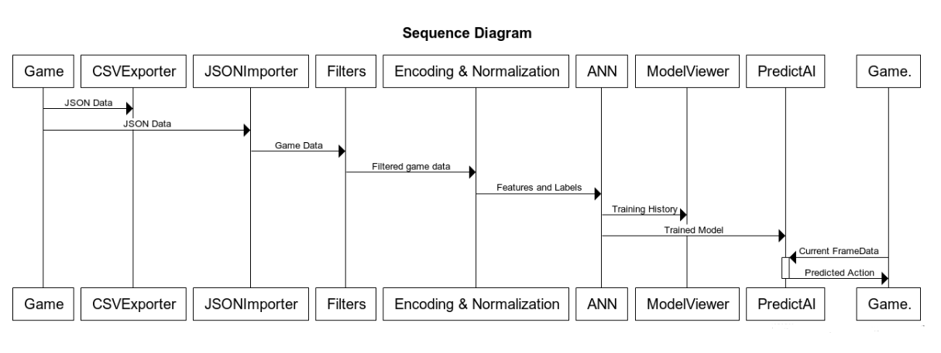

**Data Preparation Phase**

Our game data includes all frames of gameplay which consists of about 60 frames per second. It has a variety of fields such as actions taken by players, their coordinates on a computer screen, the key list that they pressed etc. It is nice to have more data, but most of the frames are repetitive or useless since most of the actions have more than one state. For example, if one player makes a STAND_A action (which is just a punch action in English words), there are 4 states;

* **Startup state**: Character starts its punching action in this state if its hitbox collides with a competitor it will not damage him.
* **Active state:** In the active state its hitbox will damage its component if it collides.
* **Recovery state:** Recovery state is responsible for displaying the pulling back hist animation.
* **Cancelable state:** If the action was taken by the player, it can not cancelable if it is not in the cancelable frame.

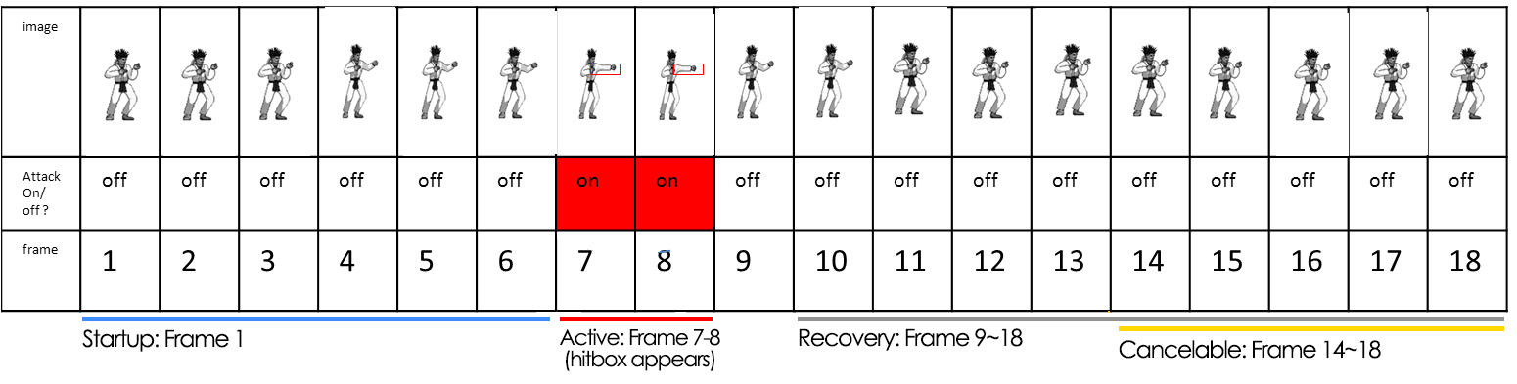

Figure 2 - Example timelapse of STAND.A Action

Because of these states and in order to make the data useful, we decided to filter these frames according to different rules and we defined the following filter functions.

* **Remove unpressed frames**

In JSON file, we can filter the frames that players pressing any key. This filter added because of the longer actions are evaluating too much in the learning system. Frames of longer actions can be reduced with using this filter.

* **Remove both standing frames**

It is pointless to keep both STAND frames for players. STAND frames reduce the efficiency of the learning system. So we are removing the frames which have both player in a STAND action.

* **Remove the same consecutive actions**

In FightingICE, every action each action consists of several frames. There is no specific measure, the duration of each action can be different frame count. So, actions with a longer count of frames are more likely to be evaluated, even if less. It is a problem with the right system. We are removing the consecutive frames that have the same action. After this step, we have only the stages that any action changes from another action.

* **Remove recov frames**

After the players have made certain movements or enemy players have made any impact action to our player, it is going back into RECOV animations. For example, when the player falls to the ground, the animation of stand up action tagged as RECOV. These types of actions can not send as an action to the game which is running. So, our learning system must not predict these actions. So the enemy can have these actions in its frames. However, we must remove them from our player. Our player can make any action when the enemy is in RECOV action.

In order to apply these rules to our data, we implemented a simple tool in Python. It was responsible for reading JSON files that automatically generated by FigthingICE platform and generating CSV files after applying these rules. We will use these CSV files to feed our data to our artificial neural network.

It was used easily with the command line arguments and it did a good job. Nevertheless, we noticed that generating CSV files is unnecessary in this context and it was slowing our work because with using this solution we read our data from disk twice and write once. For example; if we want to prepare one JSON file with this solution; we have to open it, apply filters, and wrote it back to disk as CSV format. After that, we have to open CSV files in the machine learning phase. Besides that, we were working with Jupyter Notebook because of its powerful features such as live coding feature and this solution is not the best way to use with live coding technique.

To overcome these problems, we designed the core package which includes helper functions and objects to automate the data preparation phase and integrate our data into our artificial neural networks.

To begin with, we implemented the GameData object. It is responsible for representing our data in the memory. We can apply our rules to this GameData object with predefined filters that can be found in filters.py file. Moreover, it has a lot of helper features, for example; this object can provide statistics about the data, we can visualize this data with beautiful Python library which name is pandas and it implements Python’s iteration mechanism so it can be used easily with built-in for or while loops without any harm.

Secondly, we implemented some helper functions that can be found in json_importer.py file to instantiate GameData objects from JSON. With these functions, we have to just provide file or folder name and they will return GameData object constructed from a given JSON file(s). This solution is worked very well. We read our data from disk once and we can play our data in our notebooks easily.

**Machine Learning Phase**

In the machine learning phase, we have to do some preprocessing to our data. The GameData object that constructed in the data preparation step is not doing anything about normalization, encoding or any other machine learning related task.

First of all, we will one hot encode our actions which are categorical. There is a built-in helper function for one hot encoding in scikit-learn library’s preprocessing package but it did not meet our requirements since it will do encoding with given data reasonably. Nevertheless, sometimes our game data does not contain all actions, so using this built-in function may cause some errors. To overcome this problem, we implement our version of one hot encoding since we know the actions explicitly, it was not a big deal for us. Encoding and decoding functions can be found in actions.py file under the core package.

After that, in order to normalize our non-categorical features, we used MinMaxScaler from scikit-learn’s preprocessing package. It worked with is some little problem. After the training when we adapting our artificial neural network to FightingIce platform, we needed the same Normalizer object, since it normalizes with respect to the given set of numbers. We found two solutions one of them is that we can construct a new MinMaxScaler object and provide the same set of numbers to it, another one is persisting the MinMaxScaler object to disk while we train our network. We decided to go with the second solution as we think that this will be better since we don’t need to prepare the same data again and again. To make this, we implemented the Normalizer object which can be found in preprocessing.py file under the core package. It uses scikit-learn’s MinMaxScaler and it can be persisted to disk with the Pythons pickle library. So we can easily re-construct Normalizer objects that generated and persisted to disk in the training process from disk easily.

We have constructed the same neural network models that we trained while adapting them to FightingIce platform just like the normalization part. Thanks to Keras, persisting and re-constructing models are very easy, we just used methods that provided for this task. In order to understand our neural network models’ performance, we implemented some helper functions for plotting our models’ metrics such as accuracy, loss, validation accuracy etc. Early in the project, we will save plots as images to show to our instructor or present in the report but we noticed that instead of storing images if we store the training history which is provided by Keras, we can plot new plot types in the future such as confusion matrix. In order to that, we used pickle to persist history object which includes training history that returned from the training run.

After all of these, we extended the GameData object in order to add noise to our data, in order to prevent possible overfits.

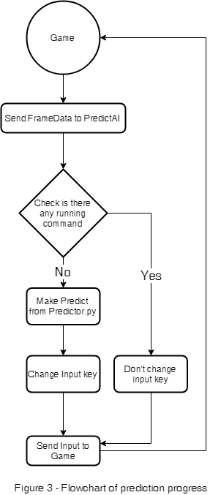**Adapting to the Game**

After the learning process, we have the files that are normalization files of each non-categorical field, history file of training history and model file which includes weights and designs of the trained model. We implemented a python object which name is Predictor which can be found in predictor.py that responsible for constructing the same model with the same conditions with the training process. Users of this object just provide a raw frame to its predict function and it will return predicted action. The meaning of the raw frame, users of this Predict object do not have to deal with machine learning tasks such as normalization or encoding, it will do these internally.

When the game is running, we can get the current frame states from the FrameData object which is given by AIInterface of FightingIce. Since making unnecessary predictions is a loss, we do not send information to the Predictor object, if an action is already started. However, some skills are cancelable when their real frames over, on the other words while they are in their cancelable state. We are checking if current action is in the cancelable frames. If it is, we are predicting new action to do.

**Tools and Techniques Used**

We decided to use FigthingIce platform for our project. It was developed for AI competitions and it provides a lot of functionalities such as providing game play data and interfaces for controlling fighters programmatically. Besides that, there are already some open sourced agents that competed in competitions. We and our advisor thought that we can use these agents to generate game play data automatically and we can learn from make clones of these agents.

The most difficult stages that we thought we could try at the beginning of the project were to learn the order of people's movement, to identify and understand all the complex movements that people did. So, we thought that the best choice for us was deep learning, and we are making supervised learning by creating many single-layered and multi-layered ANNs in order to make more successful experiments in the current and future stages of the project.

**Knowledge and Skill Set**

Firstly, main courses such as CS101, CS102, and CS201 are always included in a project. The following courses are more inspired and applied to a project.

* **CS 222 – Programming Studio**

We must work on a clean and well-designed code base to create a quality project. With the Programming Studio Course, we learned that refactoring and clean code are helpful for developing projects. We are always trying to use these principles in our project while writing code.

* **EE 393 – Python for Engineers**

We are analyzing and producing data about our game states with using Python scripts. Also, we are using Python for the purpose of the implement to training and learning steps. This course gave the knowledge about manipulating data in order to facilitate the usage of data.

* **CS 434 – Advanced Object Oriented Programming**

When we focused on gamification part of our project, we need to use a lot of design patterns to make more effective code. Using the design and architectural pattern makes our code base more understandable.

* **CS 466 – Introduction to Deep Learning**

We have to implement machine learning techniques in our project for training our agents. In the Introduction to Deep Learning course, we learned how to use neural networks for machine learning tasks. Thanks to this course, we can interpret our data with neural networks

**Engineering Standarts**

* We used Oracle’s Java xcode convention with code name 136057 for our java codes.
* We used Python’s PEP 8 style standard for our python codes.
* We used CSV files for storing our data which is created for our agents.

1. **Results and Discussion**

First of all, we wanted to prove that our structure works and also to gain experience with Keras library we implemented an arbitrary neural network that has two layers with 8 and 12 neurons. After some discussions with our instructor, we decided to train this model with simple data which was generated by us. Simple means that we followed simple strategy such that we will punch our competitor his health is less than 100, we will throw a kick if his health between 100 and 200. After the training process, it was proven that our structure works very well and we learned a lot of things from this experiment. For instance, we can improve our PredictAI object which is using for connection between FightingICE platform and our artificial neural network as we did some unnecessary calls to our even if we already started the action.

*Figure 4* 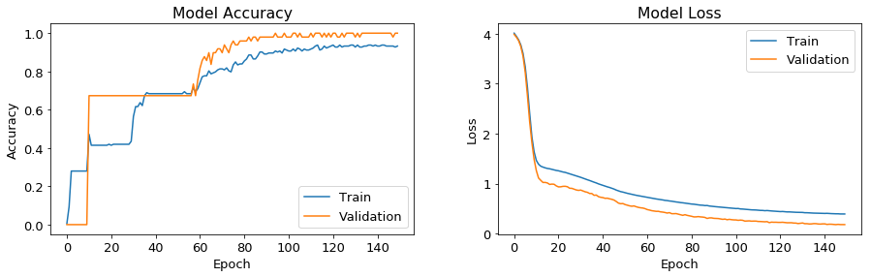

*( Accuracy and loss graphs of playing according to health experiment.)*

After this experiment, we generated hundreds of gameplay data approximately 100 games which includes 60000~ frames in total. In order to generate these sets, we used previous years competitor agents. We mainly focused on winner agent Thunder and left him to fight with other competitors which names are BCP and Utal. We will use these automatically generated data in future experiments. Also, we did not mix these two competitors game play data since one of our constraints is expecting similar movements from the learning agent and mixing can cause unexpected results.

In order to understand the effects of neuron size on training, we trained our data with a basic one hidden layer network with various neuron count from 10 to 2500. We thought that with this experiment, we will understand the impact of neuron size on training performance with working on the cross-validation – neuron count graph.

Plottings of this experiment can be found in figure 5 There 10 different networks which has one hidden layer with varying neuron count from 10 to 2500. They trained separately with the same data which generated automatically from games between Thunder and BCP agents. In our dataset, there are 50 games, we used 10 of them for validation, 5 of them for testing and 35 for training. After the training each of them 500 epochs with 16 batch we get these results.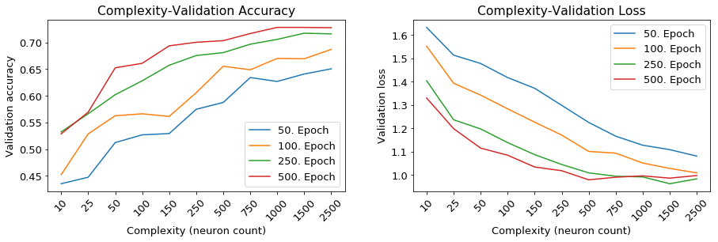

Figure 5

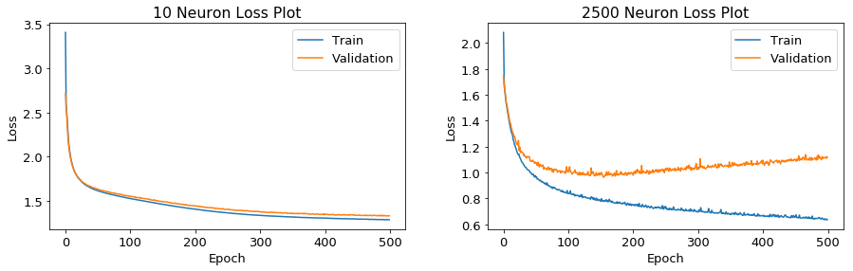(Unified validation accuracy and validation loss graphs of ANNs that has one hidden layer with varying neuron counts. These networks are trained with the matches between Thunder and BCP agents under the same conditions.)

Figure 6

(Loss plots of ANN that has one hidden layer with 10 neuron and ANN that has one hidden layer with 1500 neurons.)

We understand that complex networks learn better but these may overfit. In order to prevent overfitting, we decided to use early stop technique. In the training process, if we saw an increase in validation loss, we will stop learning.

After this, we made an experiment on a layer size. We wanted to understand the effects of layer sizes this time. We trained 4 different artificial neural networks;

- One hidden layer with 64 neurons (Network 1).

- Two hidden layers with 128 and 64 neurons (Network 2).

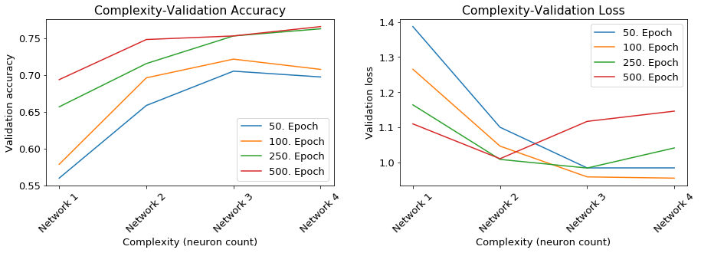- Three hidden layers with 256, 128 and 64 neurons (Network 3).

- Four hidden layers with 512, 256, 128 and 64 neurons (Network 4).

Figure 7

(Unified validation accuracy and validation loss plots of multilayer ANNs.These networks is trained with the matches between Thunder and BCP agents under the same conditions.)

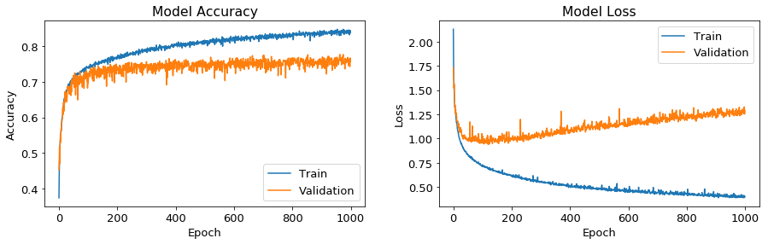Figure 8

(Accuracy and loss plots of artificial neural network that has three layers with 256, 128 and 64 neurons.*)*

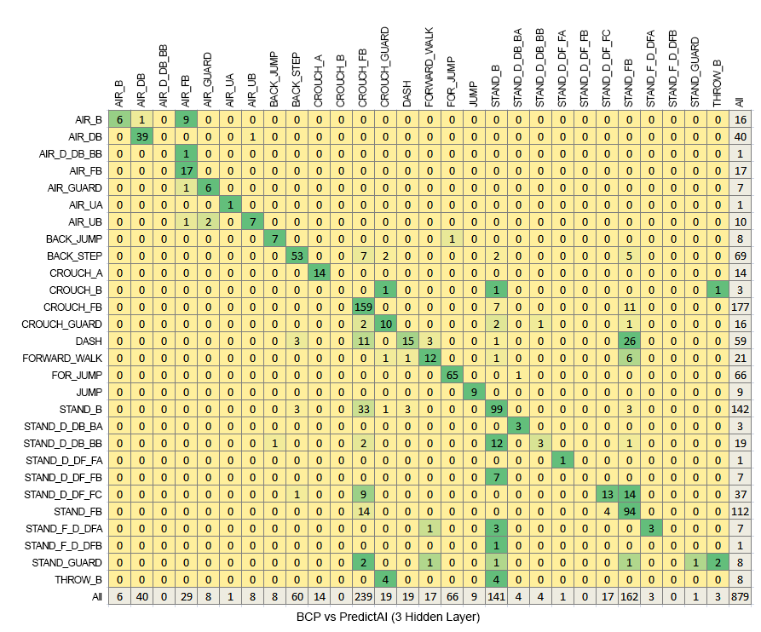Thanks to this experiment, we decided that the neural network with three layers is the most suitable one for us. We will use the weights around 200 epochs as it is the place where cross-validation loss started increasing. It reached %73 accuracy on test data and predicted 637 frames of 879 frame correctly.

Figure 9

(The confusion matrix of selected network. Diagonal cells are the correct predictions.)

To conclude, if the agent that we learned from is playing some sort of strategy, our system can clone it without any harm. Even our arbitrary network cloned us and it is capable of deciding to kick or punch according to competitors health.

1. **Related Work**

There is a competition about developing the best agents to play FightingICE game. In our project, we used different types of agents from this competition. These agents created in order to act the best performance and win the competition. When we look at this perspective, a project that is similar to our project does not exist in this competition. Because our aim is not to create clones that play the best in this process, but to create clones that mimic the best.

All of these agents can be used to create the best agent with our system in the future. If we will decide to make our system more adaptable for successful moves, there might be a comprehensive result.

Also, there is a doctoral thesis[17] from Loughborough University that trying to similar experiments with us. However, they are trying more complex structures to mimicking people's behaviors in the game.

1. **Conclusion and Future Work**

As a result, the agent we created can communicate with the model in the game and apply the predictions. When we met the necessary limitations, we are able to generate clones that predict correct actions. In the coming period, our aim is to understand the more complex structures and to make our project completely overcome each situation.

**Achievement**  
 Preparing the data is one of the most important parts of the project. Every frame of the game is including different variables. We learned to pick the most important ones to use in the learning process.  
Since using data that are useless will give the worst result to us.

Also, we achieved that we can use the ANN to train people/agent's certain behaviors that are not complex. If the player plays in the same way usually, we can easily generate an agent that cloning the behaviors of people.

Lastly, we learned how can we use the FightingICE platform to make more experiments in the future.

**Effects of our project**

* **Economics**

The use of artificial intelligence in the industry, especially in the entertainment industry, contributes to the project economically by increasing the interest of the users. On the other hand, the situation of artificial intelligence makes automated projects more profitable and useful.

* **Manufacturability**

With our technique, the difficulty of game development may decrease since developers can use the data from players who play their games to train their agents, they don’t have to implement detailed methods for their artificial intelligence.

**Future Work**

In the future, we will work on the improve our system to generate more useful clone agents. We are doing our experiments with using agents and agents are acting more complex according to their enemies. So it is not easy to combine all of the information for the create reliable agents. There are different choices to create better clones. For example, we can examine the previous actions of agents in their frames data.

We can find patterns from agents and players when they play. When we find a better way to create the best models, we can bring together in a complete game, so two clones of players can compete with each other.

Also, our advisor suggested that we can work on the combine multiple players and agents to get their successful moves. It will be useful to create a very successful agent to fight with other ones.

**Acknowledgements**

We would like to thank our advisor Erhan Öztop for his support and suggestions in every part of the project.

**References**

[1] <http://www.ice.ci.ritsumei.ac.jp/~ftgaic/index.htm>

[2] <https://www.oracle.com/technetwork/java/javase/overview/index.html>

[3] <https://www.python.org/>

[4] https://www.tensorflow.org/

[5] https://keras.io/

[6] https://www.tensorflow.org/guide/graph_viz

[7] https://matplotlib.org/

[8] http://www.numpy.org/

[9] <https://pandas.pydata.org/>

[10] https://www.py4j.org/

[11] https://virtualenv.pypa.io/en/latest/

[12] https://pypi.org/

[13] https://jupyter.org/

[14] https://code.visualstudio.com/

[15] https://git-scm.com/

[16] <https://www.google.com/drive/>

[17] https://ieeexplore.ieee.org/document/6115128

**Appendix**

* Screenshot from FightingICE platform

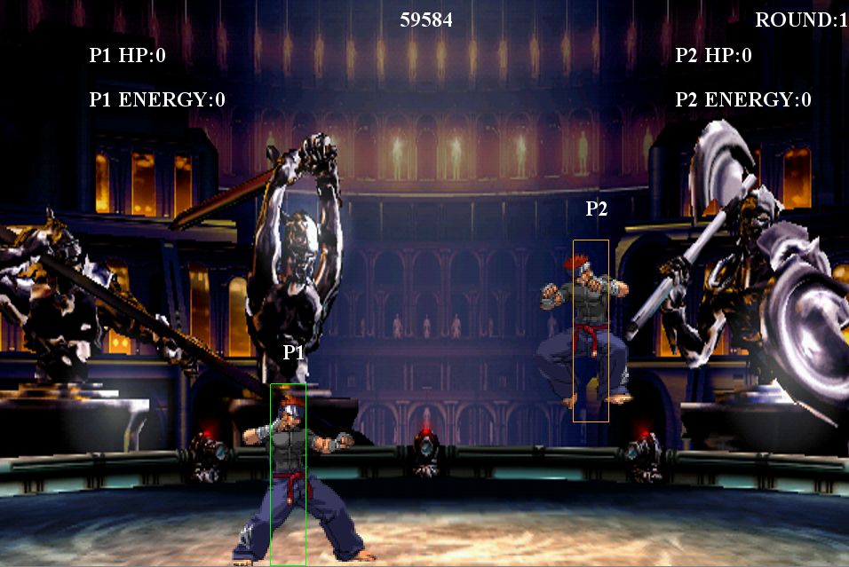

* Some additional training plots

One hidden layer ANN with 25 neurons

One hidden layer ANN with 50 neurons

One hidden layer ANN with 100 neurons



One hidden layer ANN with 150 neurons



One hidden layer ANN with 250 neurons

One hidden layer ANN with 500 neurons

One hidden layer ANN with 1000 neurons



One hidden layer ANN with 1500 neurons

Multi layer ANN with 128 and 64 neurons

Multi layer ANN with 512, 256, 128 and 64 neurons